BRADLEY BEACH ELEMENTARY SCHOOL
515 BRINLEY AVENUE
BRADLEY BEACH, NEW JERSEY 07720
TELEPHONE: (732) 775-4413
www.bbesnj.org

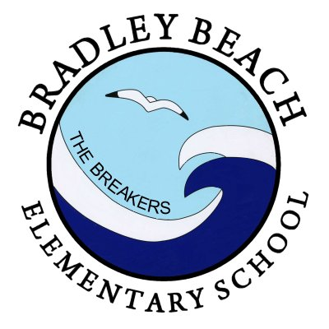
Ms. Sarah A. Poppe
Director of Curriculum/Instruction

Mrs. Alison Zylinski
Supervisor of Special Services

Elizabeth J. Franks, Ed.D.
Board President

Mr. David Tonzola
Business Administrator/Board Secretary

Dr. Stephen T. Wisniewski
Superintendent/Principal

February 10, 2020

Parents/ Guardians,

It is hard to believe, but the month of February marks the midpoint in our school year. It seems like yesterday that we were welcoming the students back from the summer, and now we set our course for the second half of the school year.

I would like to highlight a few events that will take place in the second half of February. On Wednesday, February 12th, Ms. Acerra will host a meeting for 8th Grade parents to discuss fundraising for the Washington DC trip at 6:30 PM in Room 3. School will be closed on Friday, February 14th, to allow for a staff professional day. School will also be closed on Monday, February 17th, to celebrate Presidents’ Day. The Board of Education will hold their monthly meeting on Tuesday, February 18th, at 7:00 PM in the auditorium. On Wednesday, February 19th, the PTO will hold a meeting to begin plans for this year’s Cinco de Mayo celebration. Finally, on Thursday, February 20th, Mr. LeProtto will host our annual Talent Show in the auditorium beginning at 7:00 PM.

One school event that I would like to highlight is Bradley Beach Elementary School’s music program night with the NJ Devils. The BBES music department will be performing at the Prudential Center on Thursday, March 19th, when the New Jersey Devils play the Calgary Flames. The music department will be performing on the main concourse of the Prudential Center prior to the start of the game. I encourage all members of the Bradley Beach Community to support this night event through their attendance. Tickets can be purchased online at https://fevo.me/BBES and transportation to and from the game will be provided by the school. Information can be found on the school’s website or by contacting Mr. LeProtto.

If you have any questions about items in the newsletter, or if you need clarification on any points, please do not hesitate to contact my office

Sincerely,

Dr. Stephen Wisniewski
Superintendent/Principal

